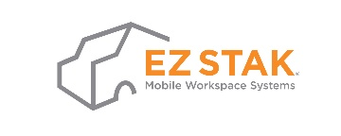
Document Name | Cell Phone Usage Policy
Document Number | M2013p
Last revised | September 13, 2022
Purpose | To ensure the cell phone is used appropriately for the business
Connecting Documents | Not applicable
Connecting Forms | Not applicable
Connecting Systems | Not applicable

Cell Phone Usage Policy

EZ STAK has decided to give you a Cell phone, for Business/Personal usage.

The following applies:

1. EZ STAK will pay per month and after that, you are responsible for the balance. This balance will be deducted off your pay cheque. We will be monitoring this monthly.

2. EZ STAK will expect you to use this Cell phone responsibly and not to abuse this privilege. As well, the Cell phone is not to be tampered with in any way.

3. If this agreement is breached in anyway, the Cell phone will be taken away.

4. As EZ STAK expects all Cell phone users to refrain from using these devices in anyway whilst driving a vehicle, since it is a safety hazard for all concerned, any incidents/accidents relating to this, will be the sole responsibility of the Cell phone user.

